Android N Evaluation

# Behavior changes:

### Battery(Doze):

Android N has added more enhancements to doze feature.For more information on optimization for doze please refer [this](https://developer.android.com/training/monitoring-device-state/doze-standby.html). If app is working fine on API level 23 then no extra work to do to target Android N.

**Impact on Product Registration**: As there is no background Sync and acquisition of wakelock operation in Product registration, Doze will not have any impact on PR.

### Project Svelte: Background Optimizations

Android N removes three implicit broadcasts in order to help optimize both memory use and power consumption.

Apps targeting Android N do not receive CONNECTIVITY_ACTION broadcasts, even if they have manifest entries to request notification of these events. Apps that are running can still listen for CONNECTIVITY_CHANGE on their main thread if they request notification with a BroadcastReceiver.

Apps cannot send or receive ACTION_NEW_PICTURE or ACTION_NEW_VIDEO broadcasts. This optimization affects all apps, not only those targeting Android N.

**Impact on Product Registration**: We are not using these intents.

### File system permission changes

Private files’ file permissions should no longer be relaxed by the owner, and an attempt to do so using MODE_WORLD_READABLE and/or MODE_WORLD_WRITEABLE, will trigger a SecurityException.

Passing file:// URIs outside the package domain may leave the receiver with an unaccessible path. Therefore, attempts to pass a file:// URI trigger a FileUriExposedException. The recommended way to share the content of a private file is using the FileProvider.

The DownloadManager can no longer share privately stored files by filename

**Impact on Product Registration**: We are not dealing with any file operation in PR. Hence there is no impact on PR.

### Accessibility Improvements:

### Not much to do if you have followed android best practices and Handling runtime changes properly.

**Impact on PR:** We have handled the configuration changes properly hence we don’t see any weird behavior on PR app.

### Multi Window Support:

With latest android N, On phones and tablets running Android N, users can run two apps side-by-side or one-above-the-other in splitscreen mode. Users can resize the apps by dragging the divider between them.

During evaluation of Product Registration app on Android N device we see some issues related to UI on split screen(Multi Window). Please refer below screenshot.

Observations:

1.       Benefits screen and product registration success screen UI looks weird.

2.       Dialogs get truncated.

3.       Other small UI issues on Product Registration screen.

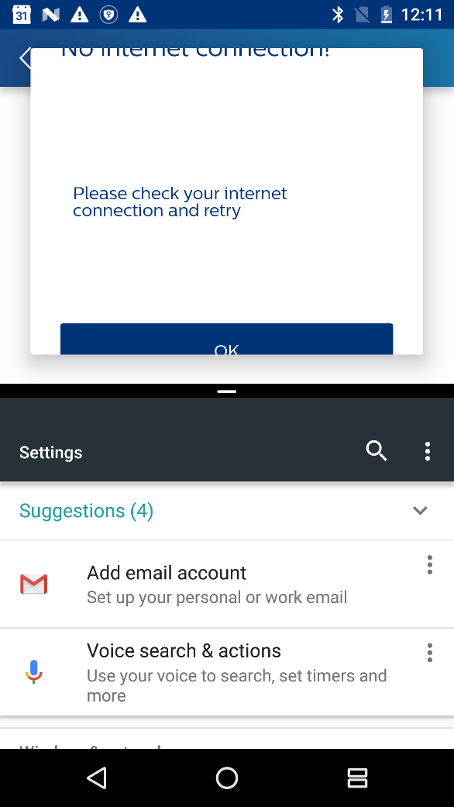

Solution:

1.       We can make complete screen(Benefits and success screens) scrollable but in that case on smartphones we will not be able to bottom align action buttons as per specs. Or Android N has feature to set minimum width and height for app. With this this we can achieve desired UI but it’s not recommended.

2.       Right now layout padding is hardcoded as per the specs. To address these UI issues we need to use layout weights. In this case we will not be able to match pixel perfect padding.